**OFFER LETTER**

**Date: 18.06.2024**

**To,**

**Mr. Siva Narayana Balaji ,**

**Hyderabad.**

**ANNEXURE**

Dear Balaji,

This is with reference to your interview held on 15-06-2024, we are pleased to inform you that you have been shortlisted for the position of **Python Developer at** **CTC 2,40,000 /-per annum**.

Your date of joining will be **20-06-2024** and you will report to the CEO.

You will be posted at our Hyderabad office and you will have a 7-day trial period and a 2-month probationary period, based on your performance during probation period your services will be confirmed further or will be ended by the employer.

Further you are requested to submit the below documents soft copy at the earliest before your joining date.

* Copies of Educational certificates.
* Copy of ID proof and address proof.
* Previous organization appointment/offer letter, last 3 months pay slips and Experience/Relieving letter.
* Bank account details – Cancelled Cheque/ passbook copy.

With Best Wishes!

**For PIXLIFY Internet Solutions**

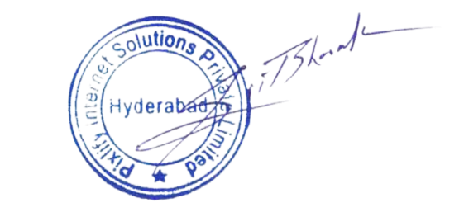blob:https://web.whatsapp.com/61851ff7-84c6-4141-9324-82e374fd82deblob:https://web.whatsapp.com/61851ff7-84c6-4141-9324-82e374fd82de blob:https://web.whatsapp.com/61851ff7-84c6-4141-9324-82e374fd82de

**Mr. Bharat Gupta**

**CEO**

| **Description** | **MONTHLY** | **ANUALLY** |
| --- | --- | --- |
| Basic salary | 10,000 | 1,20,000 |
| HRA | 4,000 | 48,000 |
| Special allowance | 4,400 | 52,800 |
| Travel allowance | 1600 | 19,200 |
| **GROSS SALARY** | **20,000** | **2,40,000** |
| PT Deduction | 150 | 1800 |
| **NET SALARY** | **19,850** | **2,38,200** |